DATA STRUCTURES & ALGORITHMS
ASSIGNMENT - SET 2
1.) A company stores employee IDs in ascending order. Write a C program that accepts n employee
IDs, searches for a required ID using Binary Search, displays its position when found, reports
when it is absent, and counts the number of comparisons. Test the program for both successful
and unsuccessful searches.

Source code:
#include <stdio.h>
int main()
{
int a[100], n, key;
int low, high, mid;
int comparisons = 0;
int found = 0;

printf("Enter number of employee IDs: ");
scanf("%d", &n);

printf("Enter employee IDs in ascending order:\n");
for (int i = 0; i < n; i++)
{
scanf("%d", &a[i]);
}

printf("Enter employee ID to search: ");
scanf("%d", &key);

low = 0;
high = n - 1;

while (low <= high)
{
mid = (low + high) / 2;
comparisons++;

if (a[mid] == key)
{
printf("Employee ID found at position %d\n", mid + 1);
found = 1;
break;
}
else if (key < a[mid])
{
high = mid - 1;
}
else
{
low = mid + 1;
}
}

if (found == 0)
{
printf("Employee ID not found\n");
}

printf("Number of comparisons = %d\n", comparisons);

return 0;
}
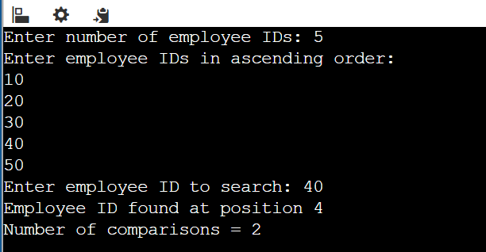
Output – Successful:

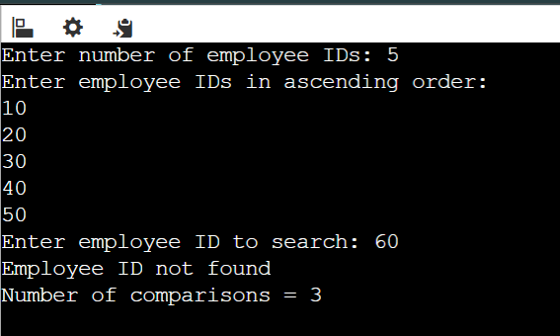
Output – Unsuccessful:

2.) A teacher wants to arrange student marks in ascending order and also measure how much
rearrangement is necessary. Write a C program using Insertion Sort that accepts n marks, displays
the array after every pass, counts the total number of element shifts, and displays the final sorted
list and shift count.

Source Code:
#include <stdio.h>
int main()
{
int a[100], n;
int i, j, key;
int shifts = 0;

printf("Enter number of marks: ");
scanf("%d", &n);

printf("Enter %d student marks:\n", n);
for (i = 0; i < n; i++)
{
scanf("%d", &a[i]);
}

// Insertion Sort
for (i = 1; i < n; i++)
{
key = a[i];
j = i - 1;

// Shift elements greater than key
while (j >= 0 && a[j] > key)
{
a[j + 1] = a[j];
shifts++;
j--;
}

a[j + 1] = key;

// Display array after each pass
printf("Pass %d: ", i);
for (int k = 0; k < n; k++)
{
printf("%d ", a[k]);
}
printf("\n");
}

// Final sorted array
printf("\nSorted marks: ");
for (i = 0; i < n; i++)
{
printf("%d ", a[i]);
}

printf("\nTotal number of shifts = %d\n", shifts);

return 0;
}
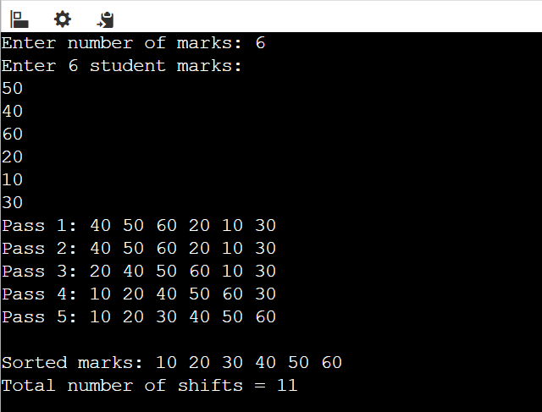
Output:
3.) An expression-processing application receives an arithmetic expression in infix form. Write a C
program using a stack to convert it to postfix form while correctly handling parentheses and
operator precedence for +, -, *, / and ^. Test the program using an expression containing multiple
operators and parentheses.
Source code:
#include <stdio.h>
#include <ctype.h>
#include <string.h>

char stack[100];
int top = -1;

// Push element into stack
void push(char ch)
{
stack[++top] = ch;
}

// Pop element from stack
char pop()
{
return stack[top--];
}

// Return precedence of operator
int precedence(char ch)
{
if (ch == '^')
return 3;
else if (ch == '*' || ch == '/')
return 2;
else if (ch == '+' || ch == '-')
return 1;
else
return 0;
}

int main()
{
char infix[100], postfix[100];
int i, j = 0;
char ch;

printf("Enter infix expression: ");
scanf("%s", infix);

for (i = 0; infix[i] != '\0'; i++)
{
ch = infix[i];

// If operand, add directly to postfix
if (isalnum(ch))
{
postfix[j++] = ch;
}

// If opening parenthesis, push into stack
else if (ch == '(')
{
push(ch);
}

// If closing parenthesis
else if (ch == ')')
{
while (top != -1 && stack[top] != '(')
{
postfix[j++] = pop();
}

pop(); // Remove '('
}

// If operator
else
{
while (top != -1 &&
stack[top] != '(' &&
precedence(stack[top]) >= precedence(ch))
{
postfix[j++] = pop();
}

push(ch);
}
}

// Pop remaining operators
while (top != -1)
{
postfix[j++] = pop();
}

postfix[j] = '\0';

printf("Postfix expression: %s\n", postfix);

return 0;
}

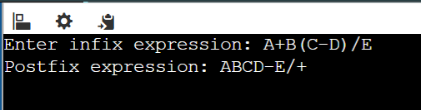
Output:

4.) A service centre uses a fixed-size request buffer in which released positions must be reused.
Write a C program to implement a Circular Queue using an array with insertion, deletion, display,
overflow and underflow operations. Demonstrate that positions freed after deletion can be reused
for new requests.
Source Code:
#include <stdio.h>

#define MAX 5

int queue[MAX];
int front = -1;
int rear = -1;

// Insert an element
void insert(int value)
{
// Check overflow
if ((rear + 1) % MAX == front)
{
printf("Queue Overflow\n");
return;
}

// First element
if (front == -1)
{
front = 0;
rear = 0;
}
else
{
rear = (rear + 1) % MAX;
}

queue[rear] = value;
printf("%d inserted into queue\n", value);
}

// Delete an element
void delete()
{
int value;

// Check underflow
if (front == -1)
{
printf("Queue Underflow\n");
return;
}

value = queue[front];

// If only one element
if (front == rear)
{
front = -1;
rear = -1;
}
else
{
front = (front + 1) % MAX;
}

printf("%d deleted from queue\n", value);
}

// Display queue
void display()
{
int i;

if (front == -1)
{
printf("Queue is empty\n");
return;
}

printf("Queue elements: ");

i = front;

while (1)
{
printf("%d ", queue[i]);

if (i == rear)
break;

i = (i + 1) % MAX;
}

printf("\n");
}

int main()
{
int choice, value;

while (1)
{
printf("\n--- CIRCULAR QUEUE ---\n");
printf("1. Insert\n");
printf("2. Delete\n");
printf("3. Display\n");
printf("4. Exit\n");

printf("Enter your choice: ");
scanf("%d", &choice);

switch (choice)
{
case 1:
printf("Enter request: ");
scanf("%d", &value);
insert(value);
break;
case 2:
delete();
break;
case 3:
display();
break;
case 4:
return 0;
default:
printf("Invalid choice\n");
}
}
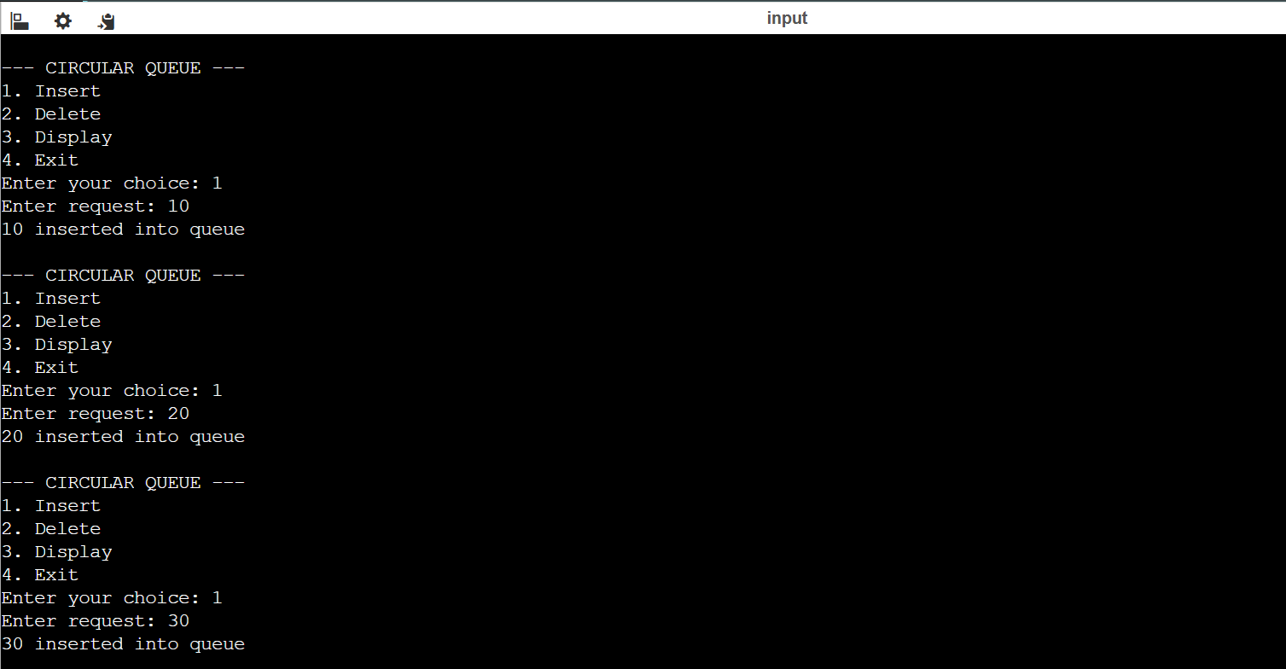
Output:

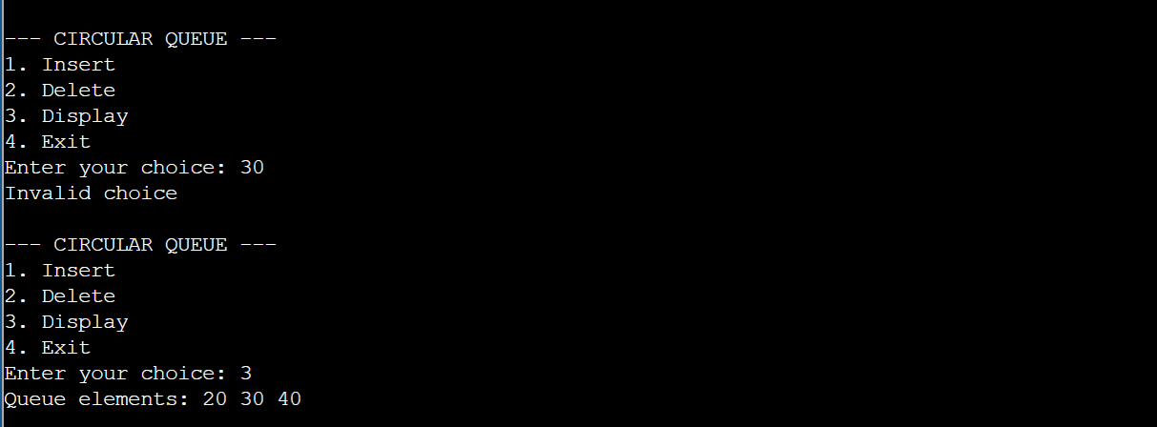
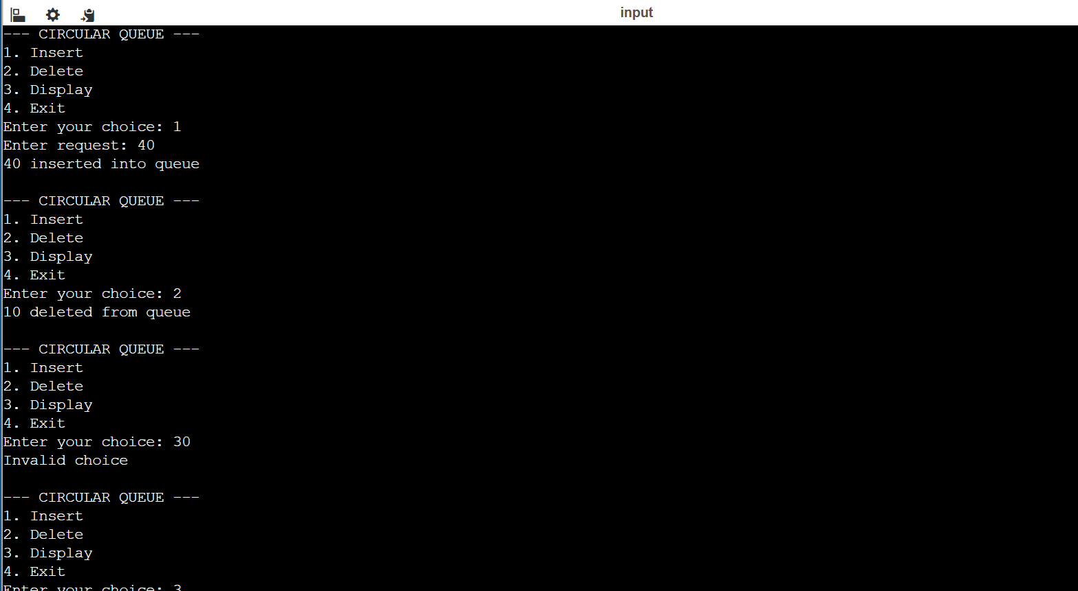
5.) A department maintains student roll numbers dynamically. Write a C program using a Singly
Linked List to create the list, insert at the beginning and end, search for a specified roll number,
delete a specified roll number, and display the updated list after each operation. Handle the case
when a requested roll number is not available.
Source Code:
#include <stdio.h>
#include <stdlib.h>

// Structure for a node
struct Node
{
int roll;
struct Node *next;
};

struct Node *head = NULL;

// Create a new node
struct Node* createNode(int roll)
{
struct Node *newNode;

newNode = (struct Node*)malloc(sizeof(struct Node));

newNode->roll = roll;
newNode->next = NULL;

return newNode;
}

// Insert at beginning
void insertBeginning(int roll)
{
struct Node *newNode = createNode(roll);

newNode->next = head;
head = newNode;

printf("Inserted %d at beginning.\n", roll);
}

// Insert at end
void insertEnd(int roll)
{
struct Node *newNode = createNode(roll);
struct Node *temp;

if (head == NULL)
{
head = newNode;
}
else
{
temp = head;

while (temp->next != NULL)
{
temp = temp->next;
}

temp->next = newNode;
}

printf("Inserted %d at end.\n", roll);
}

// Search for a roll number
void search(int roll)
{
struct Node *temp = head;
int position = 1;

while (temp != NULL)
{
if (temp->roll == roll)
{
printf("Roll number %d found at position %d.\n",
roll, position);
return;
}

temp = temp->next;
position++;
}

printf("Roll number %d not found.\n", roll);
}

// Delete a roll number
void deleteRoll(int roll)
{
struct Node *temp = head;
struct Node *prev = NULL;

if (head == NULL)
{
printf("List is empty.\n");
return;
}

// If first node has the roll number
if (head->roll == roll)
{
head = head->next;
free(temp);

printf("Roll number %d deleted.\n", roll);
return;
}

// Search for the node
while (temp != NULL && temp->roll != roll)
{
prev = temp;
temp = temp->next;
}

// Roll number not found
if (temp == NULL)
{
printf("Roll number %d not found. Cannot delete.\n", roll);
return;
}

// Delete the node
prev->next = temp->next;
free(temp);

printf("Roll number %d deleted.\n", roll);
}

// Display the list
void display()
{
struct Node *temp = head;

if (head == NULL)
{
printf("List is empty.\n");
return;
}

printf("Student Roll Numbers: ");

while (temp != NULL)
{
printf("%d -> ", temp->roll);
temp = temp->next;
}

printf("NULL\n");
}

int main()
{
int choice, roll, n, i;

printf("Enter number of students: ");
scanf("%d", &n);

printf("Enter %d roll numbers:\n", n);

for (i = 0; i < n; i++)
{
scanf("%d", &roll);
insertEnd(roll);
}

printf("\nInitial List:\n");
display();

while (1)
{
printf("\n--- SINGLY LINKED LIST ---\n");
printf("1. Insert at Beginning\n");
printf("2. Insert at End\n");
printf("3. Search\n");
printf("4. Delete\n");
printf("5. Display\n");
printf("6. Exit\n");

printf("Enter your choice: ");
scanf("%d", &choice);

switch (choice)
{
case 1:
printf("Enter roll number: ");
scanf("%d", &roll);
insertBeginning(roll);
display();
break;

case 2:
printf("Enter roll number: ");
scanf("%d", &roll);
insertEnd(roll);
display();
break;

case 3:
printf("Enter roll number to search: ");
scanf("%d", &roll);
search(roll);
break;

case 4:
printf("Enter roll number to delete: ");
scanf("%d", &roll);
deleteRoll(roll);
display();
break;

case 5:
display();
break;

case 6:
printf("Program ended.\n");
return 0;

default:
printf("Invalid choice.\n");
}
}

return 0;
}
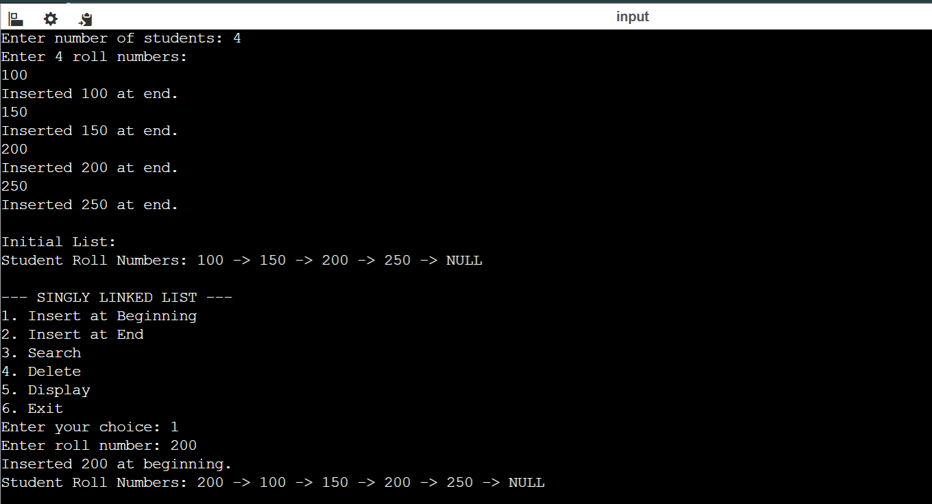
Output:
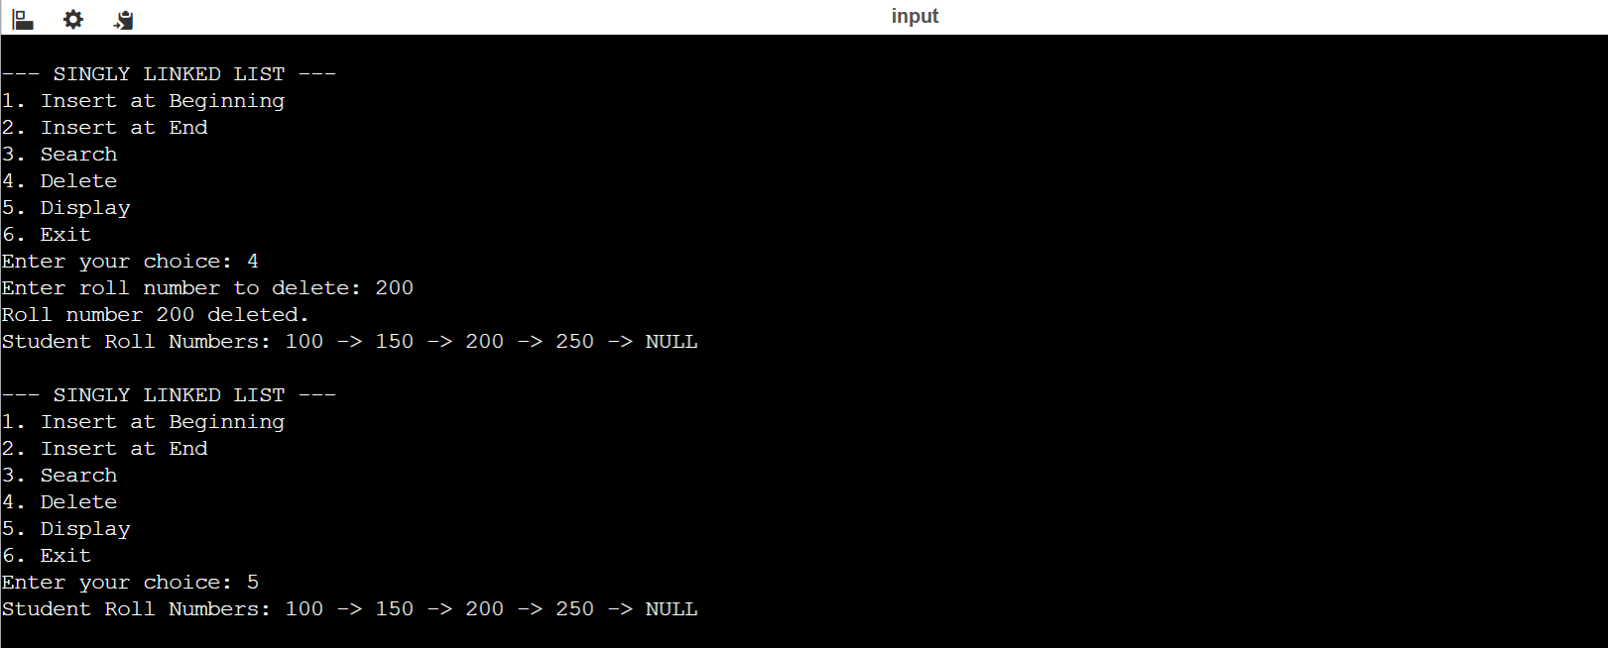

6.) Develop a C program for a Doubly Linked List representing a sequence of web pages visited by a
user. The program should insert a new page, move forward and backward, delete a specified
page, and display the pages from first-to-last and last-to-first while handling beginning and end
conditions correctly.
Source Code:
#include <stdio.h>
#include <stdlib.h>
#include <string.h>

struct Node
{
char page[50];
struct Node *prev;
struct Node *next;
};

struct Node *head = NULL;
struct Node *tail = NULL;
struct Node *current = NULL;

// Insert a new page at the end
void insertPage(char page[])
{
struct Node *newNode;

newNode = (struct Node *)malloc(sizeof(struct Node));

strcpy(newNode->page, page);
newNode->prev = NULL;
newNode->next = NULL;

if (head == NULL)
{
head = tail = current = newNode;
}
else
{
newNode->prev = tail;
tail->next = newNode;
tail = newNode;
}

printf("Page '%s' inserted.\n", page);
}

// Move forward
void moveForward()
{
if (current == NULL)
{
printf("No pages available.\n");
}
else if (current->next == NULL)
{
printf("Already at the last page. Cannot move forward.\n");
}
else
{
current = current->next;
printf("Current page: %s\n", current->page);
}
}

// Move backward
void moveBackward()
{
if (current == NULL)
{
printf("No pages available.\n");
}
else if (current->prev == NULL)
{
printf("Already at the first page. Cannot move backward.\n");
}
else
{
current = current->prev;
printf("Current page: %s\n", current->page);
}
}

// Delete a specified page
void deletePage(char page[])
{
struct Node *temp = head;

while (temp != NULL && strcmp(temp->page, page) != 0)
{
temp = temp->next;
}

if (temp == NULL)
{
printf("Page '%s' not found.\n", page);
return;
}

// If deleting the first node
if (temp == head)
{
head = temp->next;

if (head != NULL)
head->prev = NULL;
}
else
{
temp->prev->next = temp->next;
}

// If deleting the last node
if (temp == tail)
{
tail = temp->prev;

if (tail != NULL)
tail->next = NULL;
}
else
{
temp->next->prev = temp->prev;
}

// Update current page if it is deleted
if (current == temp)
{
if (temp->next != NULL)
current = temp->next;
else
current = temp->prev;
}

free(temp);

printf("Page '%s' deleted.\n", page);

if (head == NULL)
current = NULL;
}

// Display first to last
void displayForward()
{
struct Node *temp = head;

if (head == NULL)
{
printf("No pages in history.\n");
return;
}

printf("Pages First to Last:\n");

while (temp != NULL)
{
printf("%s", temp->page);

if (temp->next != NULL)
printf(" <-> ");

temp = temp->next;
}

printf("\n");
}

// Display last to first
void displayBackward()
{
struct Node *temp = tail;

if (tail == NULL)
{
printf("No pages in history.\n");
return;
}

printf("Pages Last to First:\n");

while (temp != NULL)
{
printf("%s", temp->page);

if (temp->prev != NULL)
printf(" <-> ");

temp = temp->prev;
}

printf("\n");
}

int main()
{
int choice;
char page[50];

while (1)
{
printf("\n--- WEB PAGE HISTORY ---\n");
printf("1. Insert New Page\n");
printf("2. Move Forward\n");
printf("3. Move Backward\n");
printf("4. Delete Page\n");
printf("5. Display First to Last\n");
printf("6. Display Last to First\n");
printf("7. Exit\n");

printf("Enter your choice: ");
scanf("%d", &choice);

switch (choice)
{
case 1:
printf("Enter page name: ");
scanf("%s", page);
insertPage(page);
break;

case 2:
moveForward();
break;

case 3:
moveBackward();
break;

case 4:
printf("Enter page to delete: ");
scanf("%s", page);
deletePage(page);
break;

case 5:
displayForward();
break;

case 6:
displayBackward();
break;

case 7:
printf("Program ended.\n");
return 0;

default:
printf("Invalid choice.\n");
}
}

return 0;
}

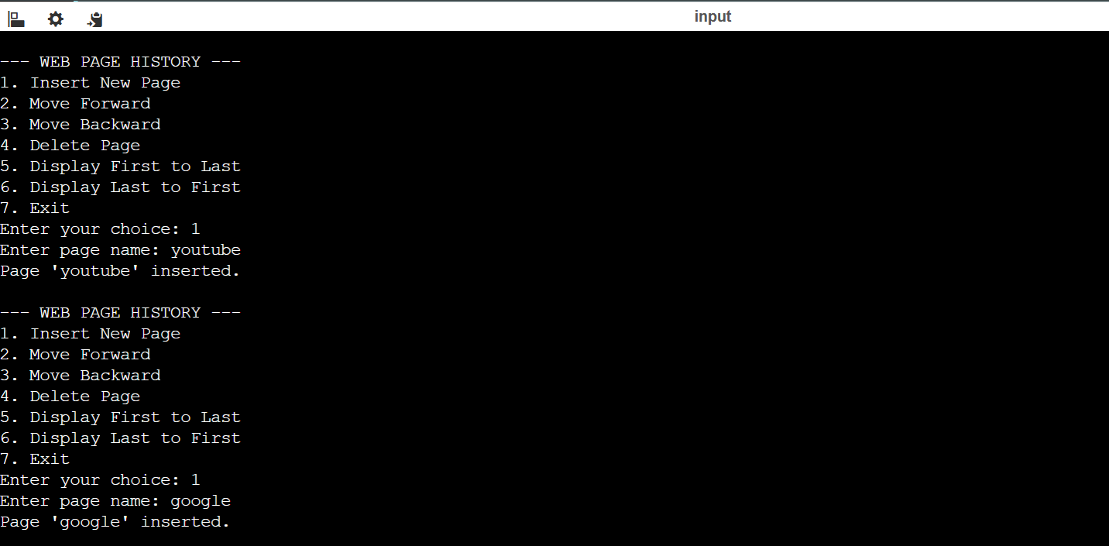
Output:
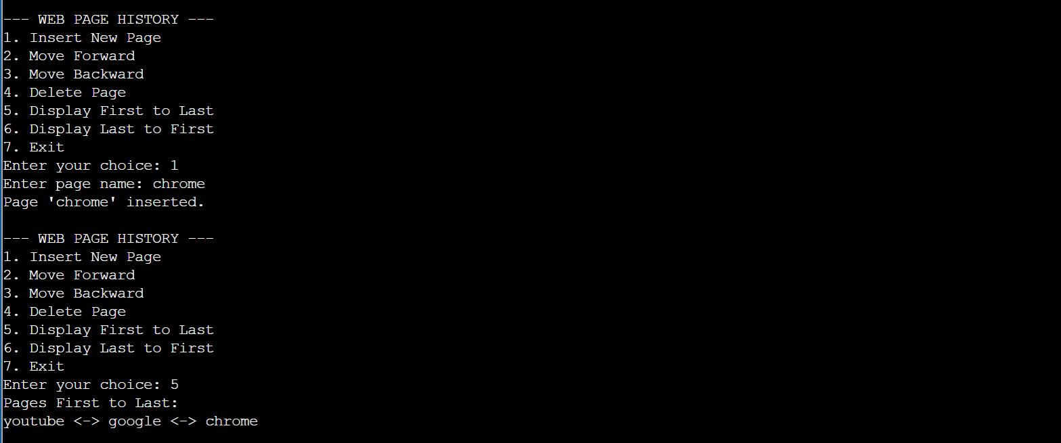
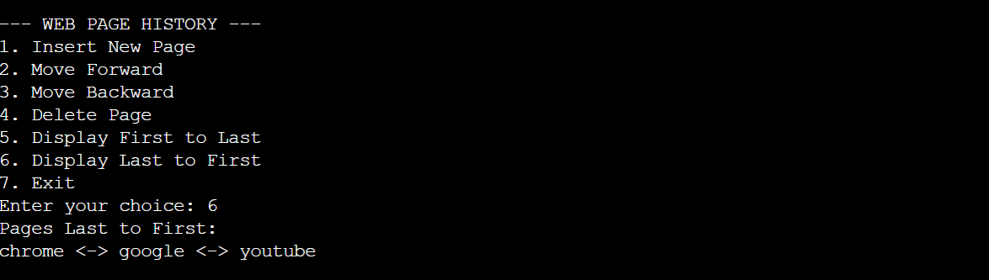

7.) A system stores unique integer identification numbers using a Binary Search Tree. Write a C
program to insert n values, display inorder, preorder and postorder traversals, search for a
specified value, and report whether it exists. Use the output to explain why inorder traversal
produces sorted values.
Source Code:
#include <stdio.h>
#include <stdlib.h>

struct Node
{
int data;
struct Node *left;
struct Node *right;
};

// Create a new node
struct Node* createNode(int value)
{
struct Node *newNode;

newNode = (struct Node*)malloc(sizeof(struct Node));

newNode->data = value;
newNode->left = NULL;
newNode->right = NULL;

return newNode;
}

// Insert a value into BST
struct Node* insert(struct Node *root, int value)
{
if (root == NULL)
{
return createNode(value);
}

if (value < root->data)
{
root->left = insert(root->left, value);
}
else if (value > root->data)
{
root->right = insert(root->right, value);
}

return root;
}

// Inorder: Left -> Root -> Right
void inorder(struct Node *root)
{
if (root != NULL)
{
inorder(root->left);
printf("%d ", root->data);
inorder(root->right);
}
}

// Preorder: Root -> Left -> Right
void preorder(struct Node *root)
{
if (root != NULL)
{
printf("%d ", root->data);
preorder(root->left);
preorder(root->right);
}
}

// Postorder: Left -> Right -> Root
void postorder(struct Node *root)
{
if (root != NULL)
{
postorder(root->left);
postorder(root->right);
printf("%d ", root->data);
}
}

// Search for a value
int search(struct Node *root, int key)
{
if (root == NULL)
return 0;

if (root->data == key)
return 1;

if (key < root->data)
return search(root->left, key);

return search(root->right, key);
}

int main()
{
struct Node *root = NULL;
int n, value, key;
int i;

printf("Enter number of values: ");
scanf("%d", &n);

printf("Enter %d unique values:\n", n);

for (i = 0; i < n; i++)
{
scanf("%d", &value);
root = insert(root, value);
}

printf("\nInorder Traversal: ");
inorder(root);

printf("\nPreorder Traversal: ");
preorder(root);

printf("\nPostorder Traversal: ");
postorder(root);

printf("\n\nEnter value to search: ");
scanf("%d", &key);

if (search(root, key))
printf("Value %d exists in the BST.\n", key);
else
printf("Value %d does not exist in the BST.\n", key);

return 0;
}
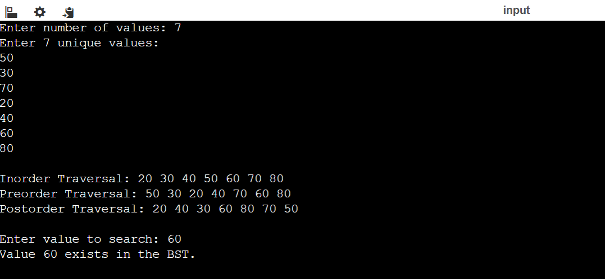
Output:

8.) Extend a Binary Search Tree program to support deletion. The program should create a BST,
delete a user-specified node, correctly handle nodes with zero, one and two children, and display
inorder traversal before and after deletion. Test the program separately for all three deletion cases.
Source Code:
#include <stdio.h>
#include <stdlib.h>

struct Node
{
int data;
struct Node *left;
struct Node *right;
};

// Create a new node
struct Node* createNode(int value)
{
struct Node *newNode;

newNode = (struct Node*)malloc(sizeof(struct Node));

newNode->data = value;
newNode->left = NULL;
newNode->right = NULL;

return newNode;
}

// Insert a node into BST
struct Node* insert(struct Node *root, int value)
{
if (root == NULL)
return createNode(value);

if (value < root->data)
root->left = insert(root->left, value);
else if (value > root->data)
root->right = insert(root->right, value);

return root;
}

// Inorder traversal
void inorder(struct Node *root)
{
if (root != NULL)
{
inorder(root->left);
printf("%d ", root->data);
inorder(root->right);
}
}

// Find the minimum value node
struct Node* findMin(struct Node *root)
{
struct Node *temp = root;

while (temp->left != NULL)
temp = temp->left;

return temp;
}

// Delete a node from BST
struct Node* deleteNode(struct Node *root, int key)
{
struct Node *temp;

if (root == NULL)
return root;

// Search in left subtree
if (key < root->data)
{
root->left = deleteNode(root->left, key);
}

// Search in right subtree
else if (key > root->data)
{
root->right = deleteNode(root->right, key);
}

// Node found
else
{
// Case 1: No child
if (root->left == NULL && root->right == NULL)
{
free(root);
return NULL;
}

// Case 2: Only right child
else if (root->left == NULL)
{
temp = root->right;
free(root);
return temp;
}

// Case 2: Only left child
else if (root->right == NULL)
{
temp = root->left;
free(root);
return temp;
}

// Case 3: Two children
else
{
temp = findMin(root->right);

root->data = temp->data;

root->right = deleteNode(root->right, temp->data);
}
}

return root;
}

int main()
{
struct Node *root = NULL;
int n, value, key;
int i;

printf("Enter number of nodes: ");
scanf("%d", &n);

printf("Enter %d values:\n", n);

for (i = 0; i < n; i++)
{
scanf("%d", &value);
root = insert(root, value);
}

printf("\nInorder before deletion: ");
inorder(root);

printf("\nEnter node to delete: ");
scanf("%d", &key);

root = deleteNode(root, key);

printf("Inorder after deletion: ");
inorder(root);

printf("\n");

return 0;
}
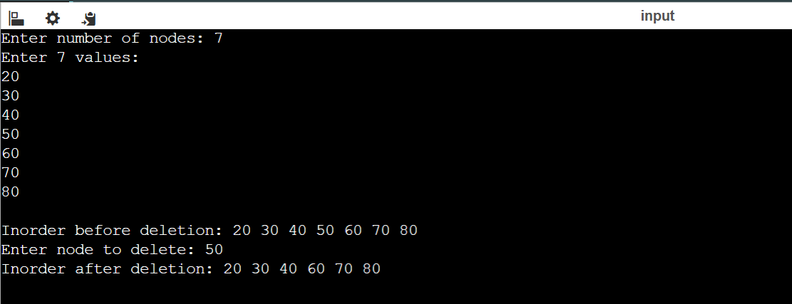
Output:

9.) A network of n locations is represented as a graph. Write a C program that accepts the graph
using an Adjacency Matrix, accepts a starting vertex, performs a graph traversal, displays the visit
order, and ensures that a vertex is not processed repeatedly. Test it with connected and partially
connected graphs.
Source Code:
#include <stdio.h>

#define MAX 20

int graph[MAX][MAX];
int visited[MAX];
int queue[MAX];

int front = -1;
int rear = -1;
int n;

// Add vertex to queue
void enqueue(int vertex)
{
if (rear == MAX - 1)
return;

if (front == -1)
front = 0;

queue[++rear] = vertex;
}

// Remove vertex from queue
int dequeue()
{
return queue[front++];
}

// BFS Traversal
void BFS(int start)
{
int i, current;

// Mark starting vertex as visited
visited[start] = 1;

enqueue(start);

printf("BFS Traversal: ");

while (front <= rear)
{
current = dequeue();

printf("%d ", current);

// Check all adjacent vertices
for (i = 0; i < n; i++)
{
if (graph[current][i] == 1 && visited[i] == 0)
{
visited[i] = 1;
enqueue(i);
}
}
}

printf("\n");
}

int main()
{
int start;
int i, j;

printf("Enter number of vertices: ");
scanf("%d", &n);

printf("Enter adjacency matrix:\n");

for (i = 0; i < n; i++)
{
for (j = 0; j < n; j++)
{
scanf("%d", &graph[i][j]);
}
}

// Initialize visited array
for (i = 0; i < n; i++)
{
visited[i] = 0;
}

printf("Enter starting vertex (0 to %d): ", n - 1);
scanf("%d", &start);

BFS(start);

return 0;
}
Output:

